DARSSHINI BABU RAJU
2025115144

1. Sum of two matrices:
#include<stdio.h>
int main()
{
int m1[10][10], m2[10][10], sum[10][10];
int r, c, i, j;
printf("Enter the number of rows and columns: ");
scanf("%d %d", &r, &c);
printf("Enter the Elements of Matrix 1:\n");
for(i=0; i<r; i++)
{
for(j=0; j<c; j++)
scanf("%d", &m1[i][j]);
}
printf("Enter the Elements of Matrix 2:\n");
for(i=0; i<r; i++)
{
for(j=0; j<c; j++)
scanf("%d", &m2[i][j]);
}
for(i=0; i<r; i++)
{
for(j=0; j<c; j++)
sum[i][j] = m1[i][j] + m2[i][j];
}
printf("\nSum of Two Matrices:\n");
for(i=0; i<r; i++)
{
for(j=0; j<c; j++)
printf("%d ", sum[i][j]);

printf("\n");
}
return 0;
}

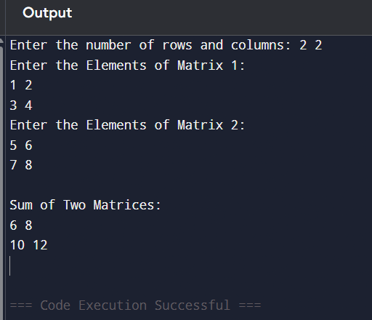

2.Write a program in C to reads n number of values in an array and display them in reverse order:

#include <stdio.h>
int main()
{
int a[100], n, i;
printf("Enter number of elements: ");
scanf("%d",&n);
printf("Enter the elements:\n");
for(i=0;i<n;i++)
{
scanf("%d",&a[i]);
}
printf("Reverse array:\n");
for(i=n-1;i>=0;i--)
{
printf("%d ",a[i]);
}
return 0;
}

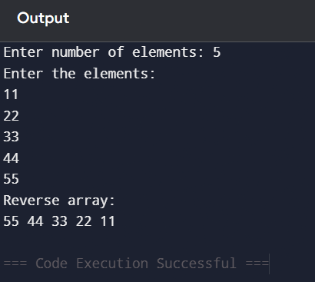

3.Count the total numbers of duplicate elements in an array:
#include <stdio.h>
int main()
{
int a[100], n, i, j, count=0;
printf("Enter the number of elements: ");
scanf("%d",&n);
printf("Enter elements:\n");
for(i=0;i<n;i++)
{
scanf("%d",&a[i]);
}
for(i=0;i<n;i++)
{
for(j=i+1;j<n;j++)
{
if(a[i]==a[j])
{
count++;
break;
}
}
}
printf("Duplicate elements = %d",count);
return 0;
}

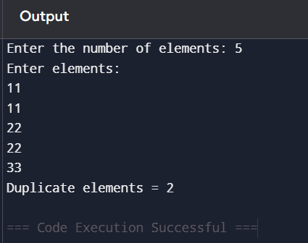

4.Print unique element in an array:
#include <stdio.h>
int main()
{
int n, i, j, count;
int arr[100];
printf("Enter number of elements: ");
scanf("%d", &n);
printf("Enter %d elements:\n", n);
for(i = 0; i < n; i++)
scanf("%d", &arr[i]);
printf("Unique elements:\n");
for(i=0; i<n; i++)
{
count = 0;
for(j=0; j<n; j++)
{
if(arr[i] == arr[j])
count++;
}
if(count == 1)
printf("%d ", arr[i]);
}
return 0;
}
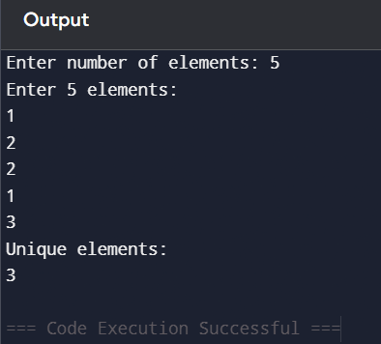
5.Insert in sorted array:
#include<stdio.h>
int main()
{
int n, Arr[100], i, value, pos;
printf("Enter the number of elements:");
scanf("%d", &n);
printf("Enter sorted array:\n");
for(i=0; i<n; i++)
scanf("%d", &Arr[i]);
printf("Enter the number to insert:");
scanf("%d", &value);
pos = n;
for(i=0; i<n; i++)
{
if(value < Arr[i])
{
pos = i;
break;
}
}
for(i=n; i>pos; i--)
Arr[i] = Arr[i-1];
Arr[pos] = value;
n++;
printf("Array after insertion:\n");
for(i = 0; i < n; i++)
printf("%d ", Arr[i]);

return 0;
}
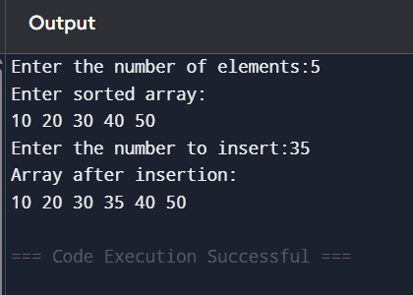

6.Insert in unsorted array:
#include<stdio.h>
int main()
{
int n, Arr[100], i, value, pos;
printf("Enter the number of elements:");
scanf("%d", &n);
printf("Enter the array elements:\n");
for(i=0; i<n; i++)
{
scanf("%d", &Arr[i]);
}
printf("Enter the number to insert:");
scanf("%d", &value);
printf("Enter the position to insert:");
scanf("%d", &pos);
for(i=n; i>=pos; i--)
{
Arr[i] = Arr[i-1];
}
Arr[pos-1] = value;
n++;
printf("Array after insertion:\n");
for(i=0; i<n; i++)
{
printf("%d ", Arr[i]);
}
return 0;
}

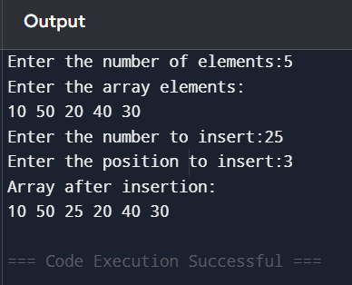

7.Matrix multiplication:
#include <stdio.h>
int main()
{
int m1[10][10], m2[10][10], product[10][10];
int r1, c1, r2, c2;
int i, j, k;
printf("Enter rows and columns of matrix 1: ");
scanf("%d %d", &r1, &c1);
printf("Enter rows and columns of matrix 2: ");
scanf("%d %d", &r2, &c2);
if(c1 != r2)
{
printf("Matrix multiplication is not possible.\n");
return 0;
}
printf("Enter first matrix:\n");
for(i=0; i<r1; i++)
{
for(j=0; j<c1; j++)
{
scanf("%d", &m1[i][j]);
}
}
printf("Enter second matrix:\n");
for(i=0; i<r2; i++)
{
for(j=0; j<c2; j++)
{
scanf("%d", &m2[i][j]);
}
}
for(i=0; i<r1; i++)
{
for(j=0; j<c2; j++)
{
product[i][j] = 0;
for(k=0; k<c1; k++)
product[i][j] += m1[i][k] * m2[k][j];
}
}
printf("Product matrix:\n");
for(i=0; i<r1; i++)
{
for(j=0; j<c2; j++)
{
printf("%d ", product[i][j]);
}
printf("\n");
}
return 0;
}
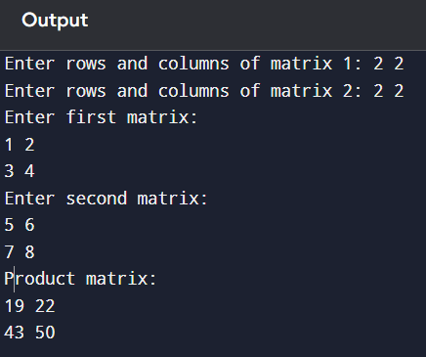

8.Matrix transpose:
#include <stdio.h>
int main()
{
int a[10][10], r, c, i, j;
printf("Enter rows and columns: ");
scanf("%d%d",&r,&c);
printf("Enter matrix:\n");
for(i=0;i<r;i++)
for(j=0;j<c;j++)
scanf("%d",&a[i][j]);
printf("Transpose Matrix:\n");
for(i=0;i<c;i++)
{
for(j=0;j<r;j++)
printf("%d ",a[j][i]);
printf("\n");
}
return 0;
}
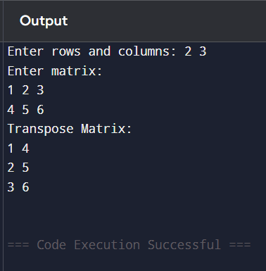

9.Right diagonal sum:
#include<stdio.h>
int main()
{
int a[10][10];
int n, i, j, sum = 0;
printf("Enter order of square matrix: ");
scanf("%d", &n);
printf("Enter matrix elements:\n");
for(i=0; i<n; i++)
{
for(j=0; j<n; j++)
{
scanf("%d", &a[i][j]);
}
}
for(i=0; i<n; i++)
{
sum += a[i][n-1-i];
}
printf("Right Diagonal Sum = %d\n", sum);
return 0;
}
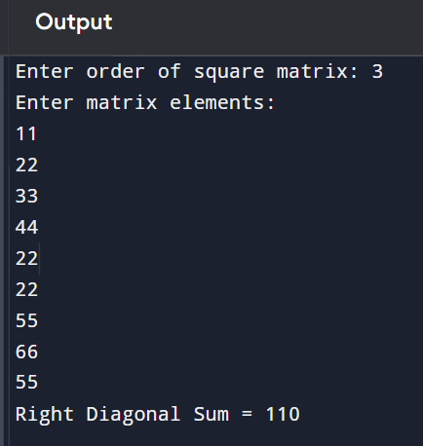

10.Check for identity matrix:
#include<stdio.h>
int main()
{
int a[10][10];
int n, i, j, flag = 1;
printf("Enter order of square matrix: ");
scanf("%d", &n);
printf("Enter matrix elements:\n");
for(i=0; i<n; i++)
{
for(j=0; j<n; j++)
{
scanf("%d", &a[i][j]);
}
}
for(i=0;i<n;i++)
{
for(j=0;j<n;j++)
{
if(i==j && a[i][j]!=1)
{
flag=0;
}
if(i!=j && a[i][j]!=0)
{
flag=0;
}
}
}

if(flag)
{
printf("Identity Matrix");
}
else
{
printf("Not an Identity Matrix");
}
return 0;
}
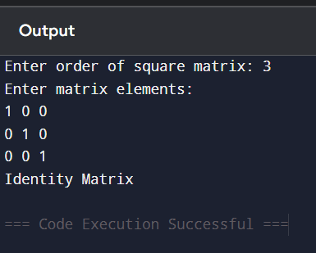

11.To find number of vowels, consonants, digits and white spaces:
#include <stdio.h>
int main()
{
char str[100];
int i, v=0, c=0, d=0, s=0;
printf("Enter a string:\n");
scanf("%[^\n]", str);
for(i=0; str[i] != '\0'; i++)
{
if(str[i]=='a' || str[i]=='e' || str[i]=='i' || str[i]=='o' || str[i]=='u' ||
str[i]=='A' || str[i]=='E' || str[i]=='I' || str[i]=='O' || str[i]=='U')
{
v++;
}
else if((str[i]>='A' && str[i]<='Z')||(str[i]>='a'&&str[i]<='z'))
{
c++;
}
else if(str[i]>='0' && str[i]<='9')
{
d++;
}
else if(str[i]==' ')
{
s++;
}
}
printf("Vowels = %d\n", v);
printf("Consonants = %d\n", c);
printf("Digits = %d\n", d);
printf("White spaces = %d\n", s);
return 0;
}
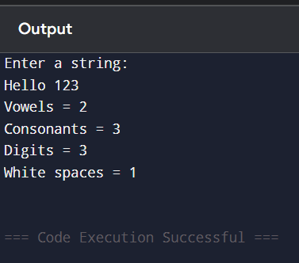

12.Frequency of a character in a sting:
#include <stdio.h>
int main()
{
char str[100];
int freq[256] = {0}, i;
printf("Enter a string: ");
scanf("%[^\n]", str);
for(i = 0; str[i] != '\0'; i++)
{
freq[(int)str[i]]++;
}
for(i = 0; i < 256; i++)
{
if(freq[i] != 0)
{
printf("%c = %d\n", i, freq[i]);
}
}
return 0;
}
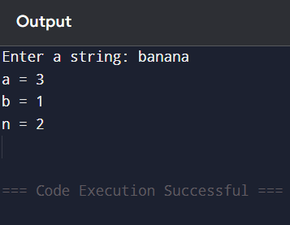

13.Count words in a string:
#include <stdio.h>
int main()
{
char str[100];
int i, words = 1;
printf("Enter sentence:\n");
scanf("%[^\n]", str);
for(i=0; str[i] != '\0'; i++)
{
if(str[i] == ' ')
{
words++;
}
}
printf("Number of words = %d", words);
return 0;
}
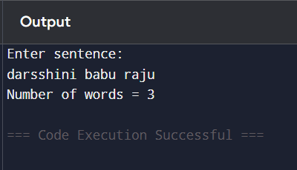

14.Sort string array:
#include<stdio.h>
#include <string.h>
int main()
{
char str[10][30], temp[30];
int n, i, j;
printf("Enter number of strings: ");
scanf("%d", &n);
printf("Enter strings:\n");
for(i=0;i<n;i++)
{
scanf("%s", str[i]);
}

for(i=0; i<n-1; i++)
{
for(j=i+1; j<n; j++)
{
if(strcmp(str[i], str[j]) > 0)
{
strcpy(temp, str[i]);
strcpy(str[i], str[j]);
strcpy(str[j], temp);
}
}
}
printf("Sorted strings:\n");
for(i=0;i<n;i++)
{
printf("%s\n",str[i]);
}
return 0;
}
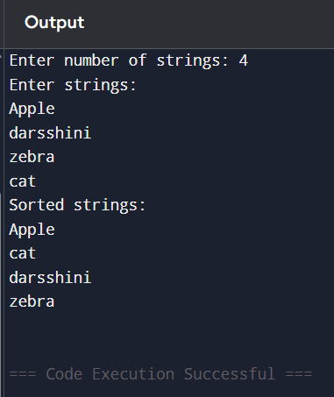

15.Toggle case of sentence (Lowercase to uppercase and viceversa):
#include <stdio.h>
int main()
{
char str[100];
int i;
printf("Enter sentence:\n");
scanf("%[^\n]", str);
for(i=0; str[i] != '\0'; i++)
{
if(str[i] >= 'A' && str[i] <= 'Z')
{
str[i] = str[i] + 32;
}
else if(str[i] >= 'a' && str[i] <= 'z')
{
str[i] = str[i] - 32;
}
}
printf("After toggle:\n%s", str);
return 0;
}
